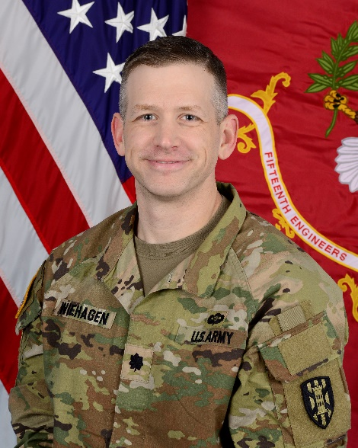LTC Mike Wiehagen commissioned as an Engineer Officer through ROTC at Case Western Reserve University, Cleveland, OH in 2006.

He served in key developmental positions as a platoon leader in 2nd Infantry Division (Korea), the commander of Bravo Company, 249th Engineer Battalion (Prime Power), the Executive Officer in 11th Engineer Battalion, and the Brigade Operations Officer in 2nd Infantry Division Sustainment Brigade.

Mike’s other assignments include Maneuver Advisor for 3-3-3 Military Transition Team in Iraq, Project Manager with the Los Angeles District at Fort Irwin, CA, a Strategic Planner in the Combined Joint Plans office for Resolute Support in Afghanistan, and the Engineer Major and Lieutenant Colonel Career Manager for Human Resources Command. His most recent assignment was serving as a Special Assistant to the Commander, U.S. European Command / Supreme Allied Commander Europe.

His civilian education includes a Bachelor of Science in Mechanical Engineering from Case Western Reserve University and a Master of Science in Energy, Science, Technology, and Policy from Carnegie Mellon University. He is also a registered Project Management Professional.

His military education includes the Engineer Basic Officer Leadership Course, Airborne School, the Engineer Captain’s Career Course, Naval College of Command and Staff, and the Advanced Military Studies Program.

Mike is a native of Harrison City, PA. He is married to Kim Wiehagen from Seoul, Republic of Korea. They have two children, Joshua (12) and Heidi (10).