Lieutenant Colonel Benjamin R. Ecklor

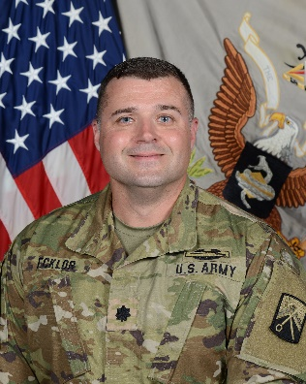LTC Ecklor is from Fort Wayne, Indiana and commissioned as an Infantry Officer in 2004 then transferred to the Finance Corps in 2008.

LTC Ecklor currently serves as the Battalion Commander of the 106th Finance Battalion, headquartered at Kleber Kaserne in Kaiserslautern, Germany, with units spread across Germany, Italy, Poland, and Romania.

**MILITARY AND CIVILIAN EDUCATION:** LTC Ecklor earned a Bachelor’s of Arts degree in Criminal Justice and Psychology from Indiana University in Bloomington, Indiana (2004). He also earned a Masters of Business Administration and an Executive Masters of Public Administration from Syracuse University in Syracuse, New York (2016). He is a graduate of the Infantry Officer Basic Course, Fort Benning, GA (2005), the Finance Captain Career Course, Fort Jackson, South Carolina (2008), and the Command and General Staff Officer Course, Fort Leavenworth, Kansas (2015).

**ASSIGNMENT HIGHLIGHTS:** After commissioning LTC Ecklor’s first assignment was as Platoon Leader, 2-8 INF, 2BCT, 4ID in support of Operation Iraqi Freedom 06-07. 2007-2008, he served as the Company Commander of D/1-50 Infantry One Station Unit Training (OSUT). Following this command, he was assigned as the Rear Detachment Commander of the 38th Human Resources Company in Bamberg, Germany. In November 2009, he assumed command of A/Detachment 106th Financial Management Support Company and deployed in support of Operation Enduring Freedom 10-11. Upon redeployment, LTC Ecklor was assigned as the Executive Officer of the 106th Financial Management Support Unit in Bamberg, Germany. He then served as the 16th Special Troops Battalion and 16th Sustainment Brigade Operations Officer from 2012-2013. From 2013-2014, LTC Ecklor was a Budget and Plans Officer at USARCENT G8. LTC Ecklor then served as the 176th FMSU Commander, in the Republic of Korea from August 2016-August 2018. He served as the United States Army Financial Management Command (USAFMCOM) Operational Support Team (OST) Director from 2018-2021, and most recently as the Deputy Director for the 18th Finance Support Center at Fort Knox, KY from 2021-2022.

**AWARDS AND DECORATIONS:** LTC Ecklor’s military awards and decorations include the Bronze Star Medal, Meritorious Service Medal with 3 OLC, Army Commendation Medal with 2 OLCs, Army Achievement Medal, National Defense Service Medal Afghanistan Campaign Medal with Bronze Star Device, Iraq Campaign Medal with Bronze Star Device, Global War on Terrorism Service Medal, Korea Defense Service Medal, Army Service Ribbon, Overseas Service Ribbon with numerical 3, NATO Medal, and the Combat Infantryman Badge. He is a recipient of the MG Nathan Towson Medallion from the Finance Corps Association.

LTC Ecklor has been married to his wife Leah for 19 years and they have four children: Daughters Isabella (18), Sabine (14), Alexandria (8) and his son Sebastian (10).